- Creating and Renaming Files/Directories.Create a directory named test_dir using mkdir..Inside test_dir, create an empty file called example.txt..Rename example.txt to renamed_example.txt using mv
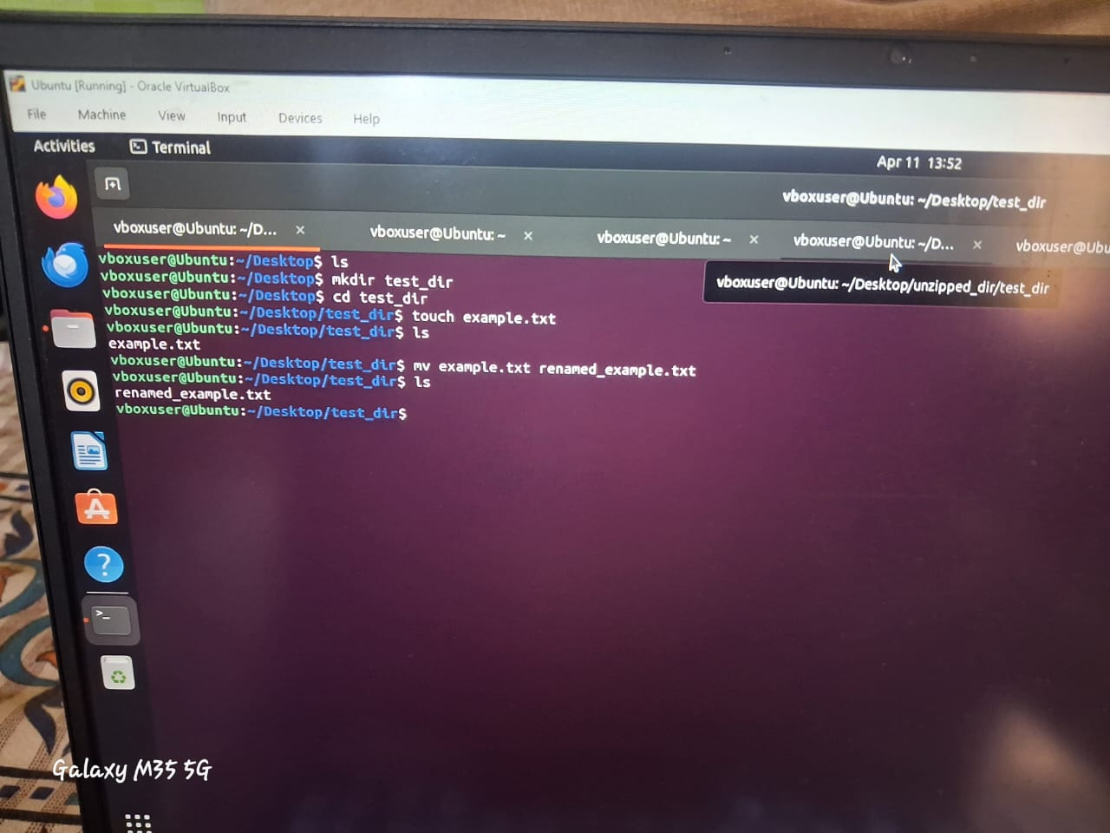

2. Viewing File Contents.Use cat to display the contents of /etc/passwd. Display only the first 5 lines of /etc/passwd using head.Display only the last 5 lines of /etc/passwd using tail.
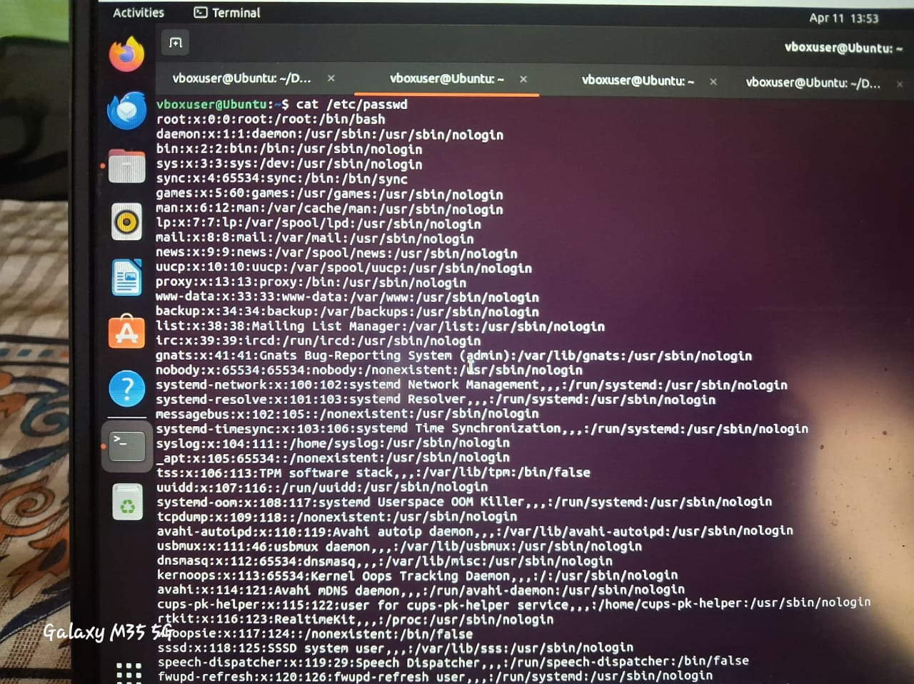
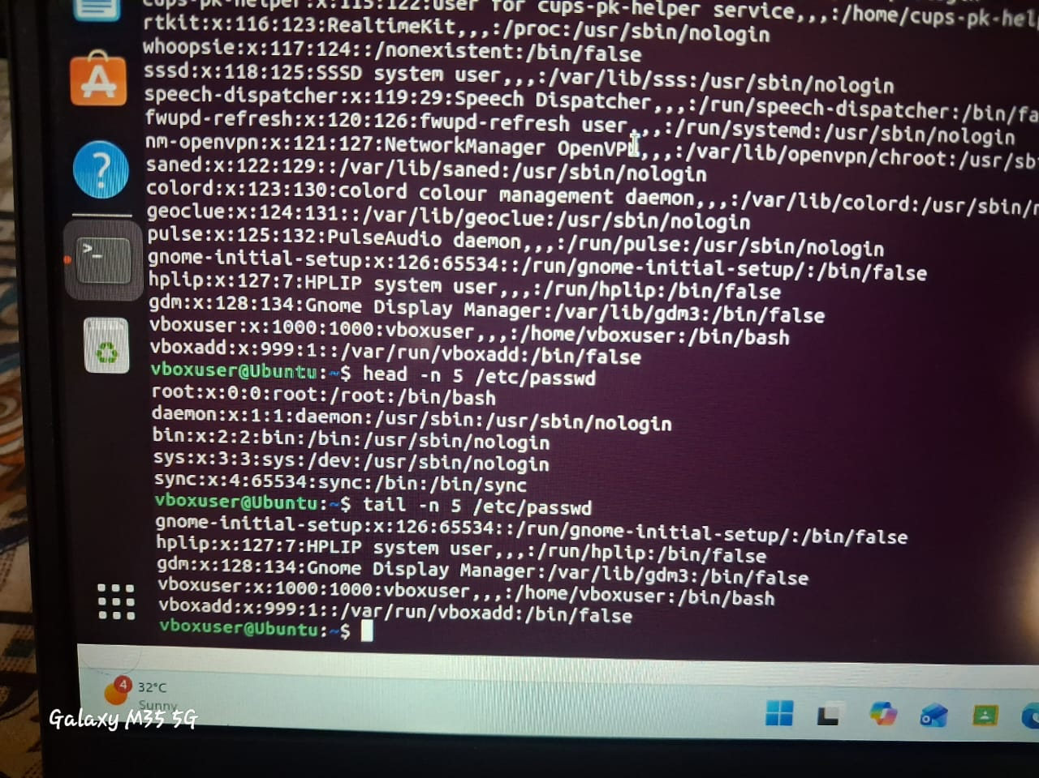
3.Searching for PatternsUse grep to find all lines containing the word "root" in /etc/passwd.
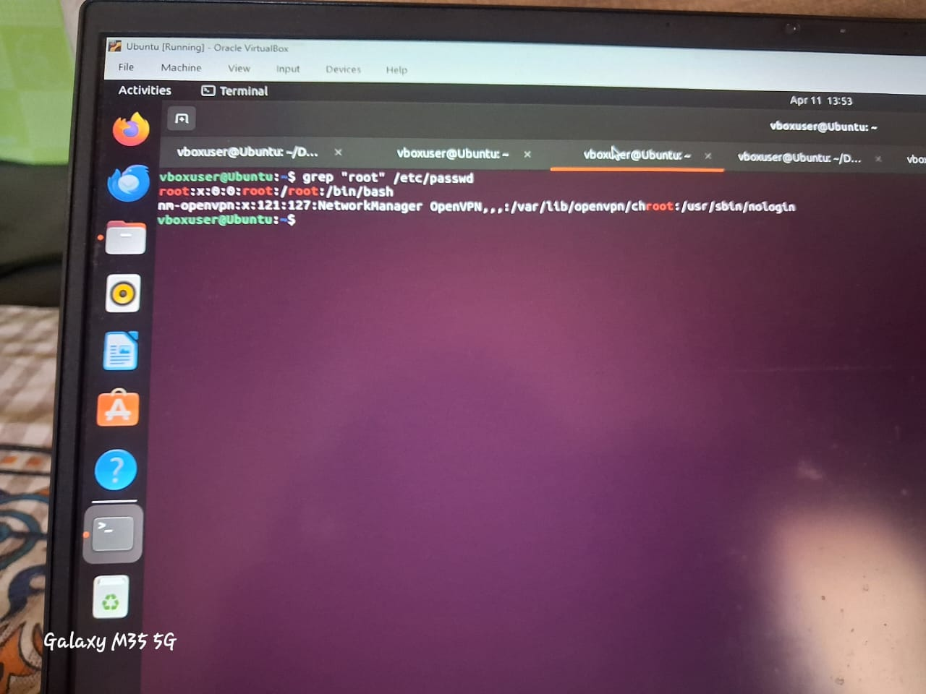

4. Zipping and Unzipping .Compress the test_dir directory into a file named test_dir.zip using zip. Unzip test_dir.zip into a new directory named unzipped_dir.
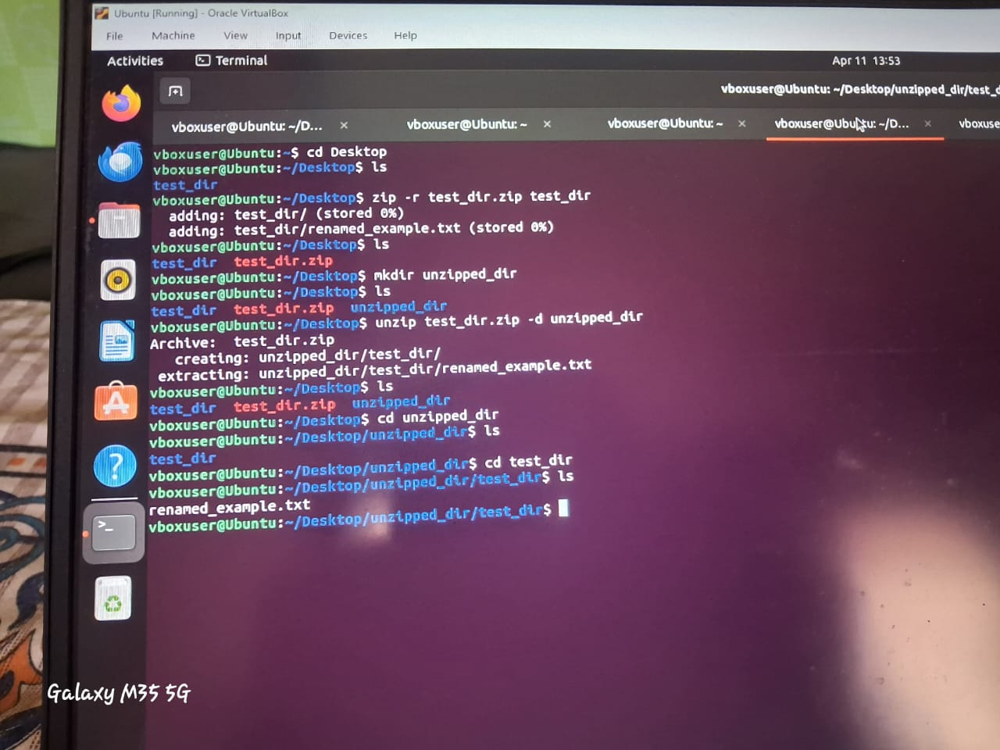
5. Downloading Files Use wget to download a file from a URL (e.g., https://example.com/sample.txt).
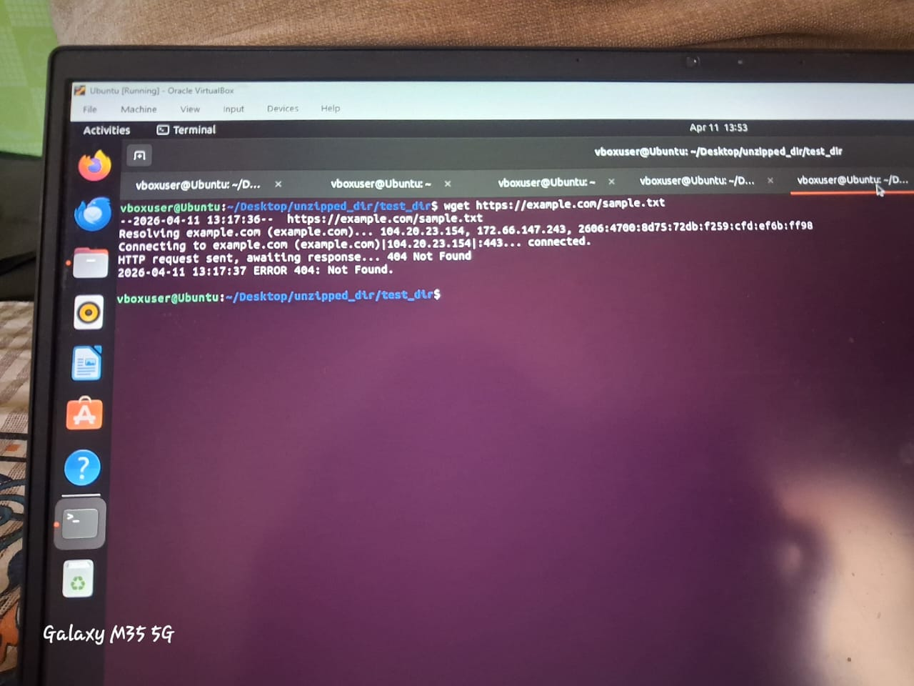
6. Changing Permissions Create a file named secure.txt and change its permissions to read-only for everyone using chmod.
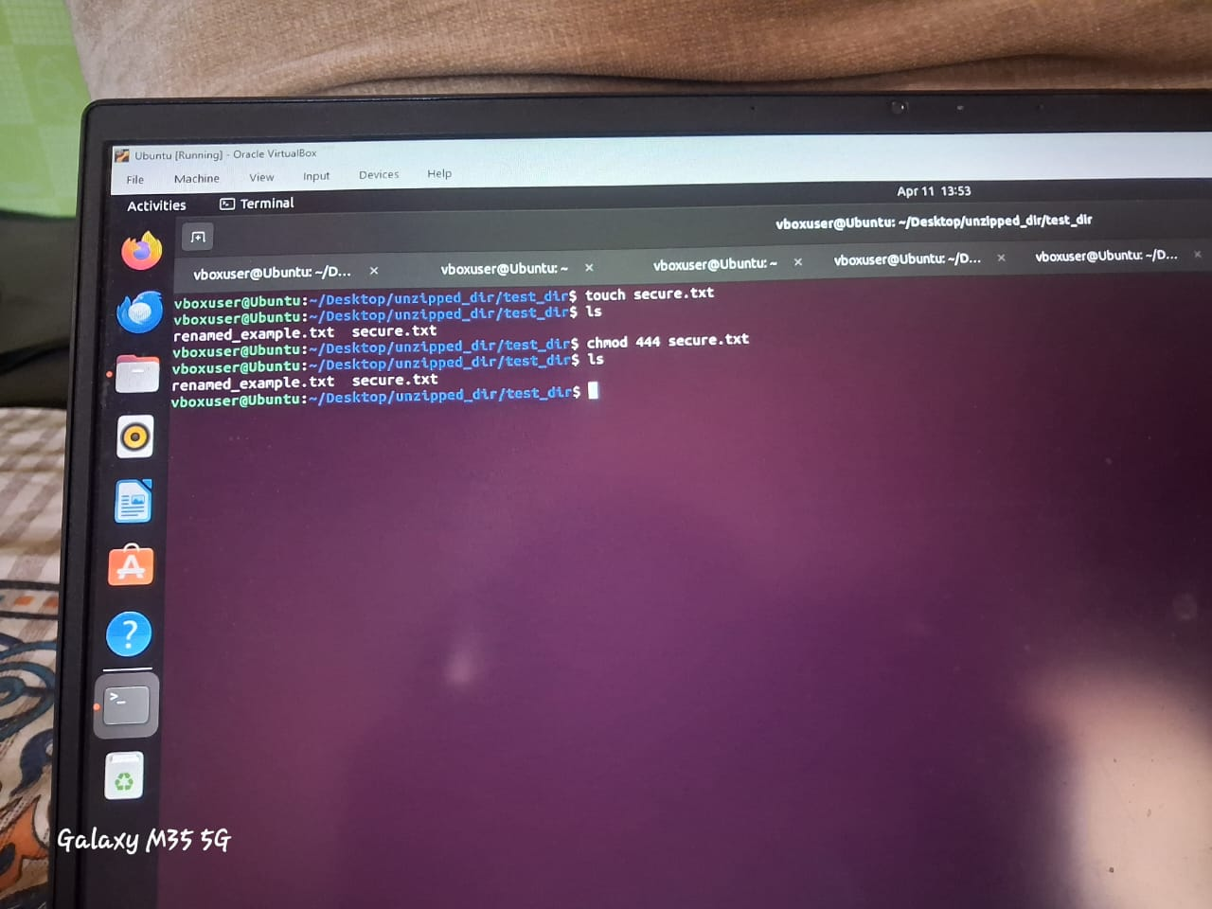
7. Working with Environment Variables Use export to set a new environment variable called MY_VAR with the value "Hello, Linux!".
